Growth rate of mushrooms

Mushrooms are living organisms but the interesting characteristic it has, is mushrooms are similar to plants when it comes to food intake and growths and become more like microorganisms when it comes to metabolism and environment.

Growth is the increment in size or other parameter while growth rate is growth in a specific time period. Mushroom growth and its growth rate can be calculated in different ways. Two different methods were used to estimate mushroom growth rate

1. Growth rate over full cycle analysis
2. Growth rate over pair differential technique

In both cases, growth was calculated in a time interval subtracting final size to the initial size within that time window. The data used for analysis is fake data(Fig.1) just prepared in order to ease the process of forecasting and initiate testing over growth rate and other forecast parameters. To estimate growth rate a time series data was used-

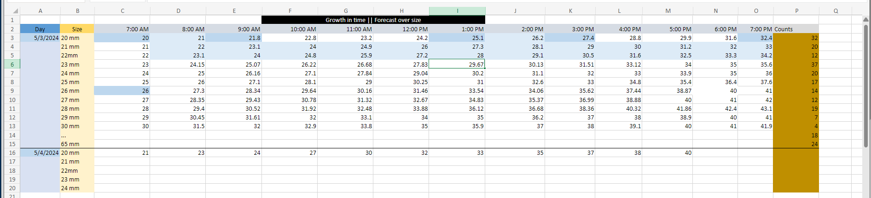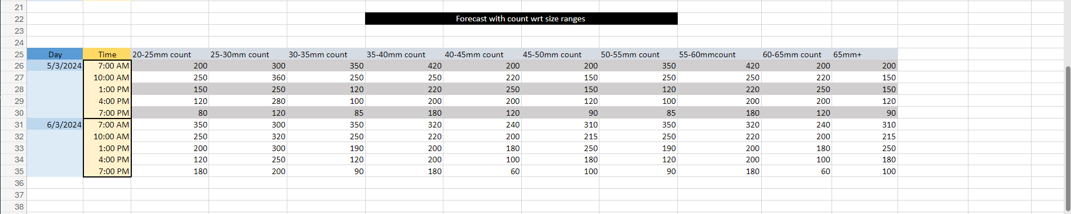

Fig.1 Sample Fake data

This is a data where individual mushroom sizes(20mm,21mm and so on) were monitored every hour and recorded what led to a time series growth data set.

Now the question is how to use this data to forecast mushroom growth ahead of time. Previously a different data set was made with counts of mushroom sizes over time and fed that to a model to predict count in 6 hours ahead given count changes every hour corresponding to each mushroom sizes as pickers carry on picking mushrooms.

Below figure (Graph.1) demonstrates how mushroom counts changes over time

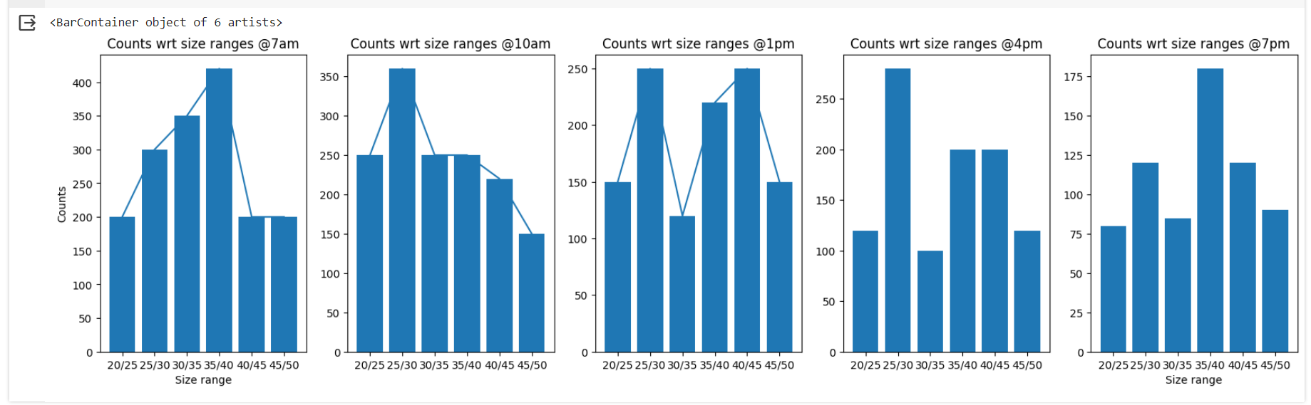Graph.1 How counts vary over time

Steps taken:

1. Understanding growth rate and how it changes over time were taken under consideration and tests were performed
2. Before jumping to growth an overview was fetched though mushroom population over each tunnel. It seems population KGs/m2 does not vary that mush tunnel to tunnel.

Graph4. and Graph.5 describes how mushroom population e.g. mushroom weight (KGs) per square meter(m2) varies in each three flushes. [Week 03 (updated).xlsx](https://universityoflincoln-my.sharepoint.com/:x:/g/personal/akundu_lincoln_ac_uk/EVVxmRl3OVlLizpEeI7_R5kBzBdwp07EcqQEO6eRpB9I_Q?e=qzbJ2z) is the dataset provided by LMF has been used to analyse KGs/M2

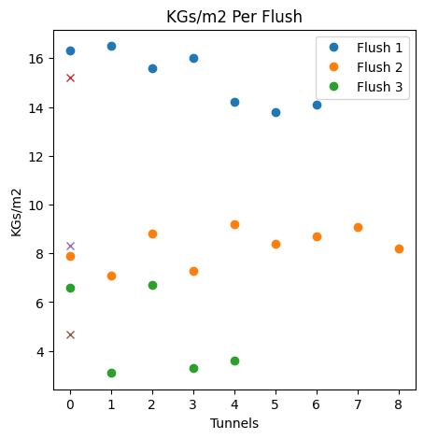

Graph4. KGs/m2 per tunnel variation

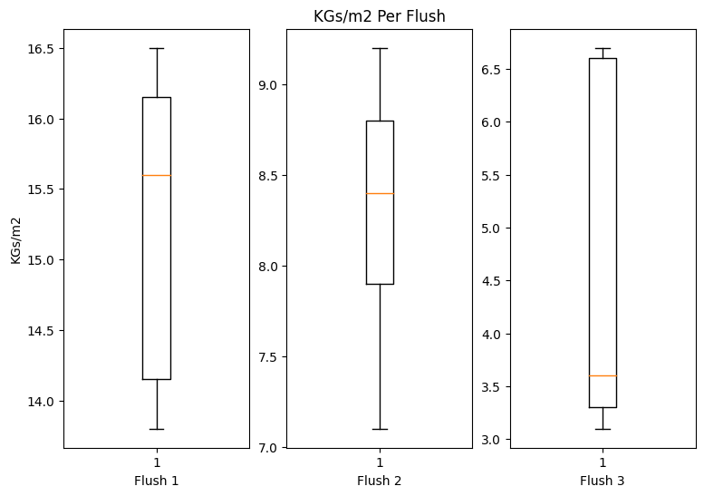

Graph5. KGs/m2 variation per flush

Growth rate

It stands out that growth rate can be evaluated in two ways-

1. Growth rate over full cycle analysis (FCA)
2. Growth rate over pair differential technique (PD)

GR over FCA

The growth was calculated over a whole 12 hours of time series data without differentiating the same into intervals e.g. Taking a whole sample of n number of time step data points and trying find growth rate within that period with respect to that time window as follows

Growth=(Final size - Initial size) at a specific time period; where Initial size= Size at the starting of the period; Final size= Size at end of that period. Time period or time window can be 3 hours long or 6 or even 12 or 24 hours long.

Growth rate= Growth / Total time; where Total time =length of the time window under consideration e.g. 3hrs,6 hrs, 12 hrs or so on

Results:

As expected, growth rate was incremental over time.

Note: The data was fake so not all the sizes will show exact same fluctuations and variations.

[GR_PDTechnique.py](https://universityoflincoln-my.sharepoint.com/:u:/g/personal/akundu_lincoln_ac_uk/Eba5BgAW94RNvBLExkIFwtMBP_I5uG9lqe3ZlZiVHmyfmw?e=4DFenL) will take data from excel sheet and will give growth rate in different intervals dividing the data in periods. The following statistical results showed up during testing-

1. Statistical data and growth rate upon scanning and monitoring the bed every hour

*** Data Captured Every 1 Hour***   
Statistical description of data over each available size   
DescribeResult(nobs=13, minmax=(20.0, 32.0), mean=25.78076923076923, variance=14.906474358974359, skewness=0.08036650092794528, kurtosis=-1.206167268164464) std: 3.8608903583207796  
DescribeResult(nobs=13, minmax=(21.0, 33.0), mean=27.04615384615385, variance=15.294358974358971, skewness=-0.01674513853568827, kurtosis=-1.2307721920962371) std: 3.910800298450302  
DescribeResult(nobs=13, minmax=(22.0, 34.2), mean=28.16923076923077, variance=16.510641025641025, skewness=0.0014235614958357675, kurtosis=-1.3098241717004027) std: 4.063328810918583  
DescribeResult(nobs=13, minmax=(23.0, 35.6), mean=29.383076923076924, variance=18.09163974358974, skewness=0.04441286492415426, kurtosis=-1.3244676456151794) std: 4.2534268235846895  
DescribeResult(nobs=13, minmax=(24.0, 36.0), mean=30.026153846153843, variance=15.016158974358971, skewness=-0.015584326615419785, kurtosis=-1.2051578270043217) std: 3.8750688993047557  
DescribeResult(nobs=13, minmax=(25.0, 37.6), mean=31.25, variance=16.787499999999994, skewness=0.016004190885846186, kurtosis=-1.2366152301990754) std: 4.097255178775176  
  
Growth over 12 hours for each sizes from 20 to 25mm-  
-----For each sizes from 20 to 25mm-----  
Growth: [12, 12, 12.2, 12.6, 12, 12.6]  
Growth rate: [1.0, 1.0, 1.0167, 1.05, 1.0, 1.05]

1. Statistical data and growth rate upon scanning and monitoring the bed every 3 hours

*** Data Captured Every 3 Hours***   
Statistical description of data over each available size from 20 to 25mm  
DescribeResult(nobs=5, minmax=(20.0, 32.0), mean=25.879999999999995, variance=22.512, skewness=0.056528342106975556, kurtosis=-1.297549433005547) std: 4.744681232706787  
DescribeResult(nobs=5, minmax=(21.0, 33.0), mean=27.060000000000002, variance=22.518, skewness=-0.04234164561032463, kurtosis=-1.3015165805005882) std: 4.7453134775270644  
DescribeResult(nobs=5, minmax=(22.0, 34.2), mean=28.120000000000005, variance=24.39200000000001, skewness=0.002512489357474378, kurtosis=-1.4045919221858005) std: 4.9388257713752175  
DescribeResult(nobs=5, minmax=(23.0, 35.6), mean=29.522, variance=25.837320000000005, skewness=-0.09004611147601829, kurtosis=-1.3800603074535875) std: 5.083042396045896  
DescribeResult(nobs=5, minmax=(24.0, 36.0), mean=30.060000000000002, variance=22.357999999999997, skewness=-0.03563939514522429, kurtosis=-1.283943043197049) std: 4.7284246848184015  
DescribeResult(nobs=13, minmax=(25.0, 37.6), mean=32.88846153846154, variance=14.14089743589743, skewness=-0.5712923294253125, kurtosis=-0.4374398797282022) std: 3.7604384632509853  
  
Growth over 12 hours for each sizes from 20 to 25mm-  
-----For each sizes from 20 to 25mm-----  
Growth: [12, 12, 12.2, 12.6, 12, 12.6]  
Growth rate: [1.0, 1.0, 1.0167, 1.05, 1.0, 1.05]

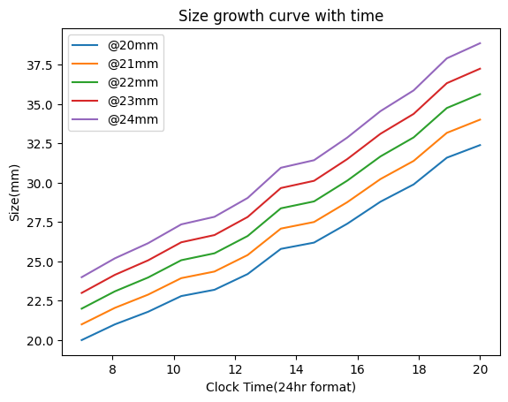

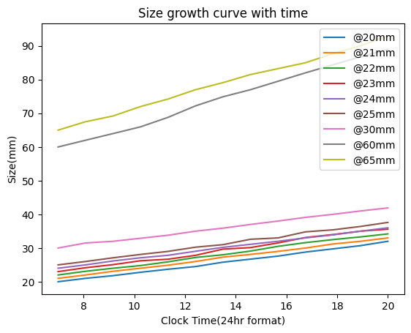

Graph6. How growth of different sizes takes place within a 12 hrs window

**Inference:**

1. Growth rate needs to be monitored in short time periods to better comprehend it.
2. The growth is likely to be linear
3. Statistical data and growth rate upon scanning and monitoring the bed in 6 hours time window resulting in two sets of data one from 7 am to 1 pm and the other from 1 pm to 7pm

*** Data divided into Every 6 Hours***   
Variance (difference) 4.13 4.932261904761903 Skewness (difference) 0.08274834000486235 0.0931242438739891  
Variance (difference) 4.916190476190477 4.38142857142857 Skewness (difference) 0.0849525865985446 0.047535068531629025  
Variance (difference) 4.716666666666666 5.0514285714285725 Skewness (difference) 0.061684561698199865 -0.2259828023169921  
Variance (difference) 5.093514285714286 5.460980952380949 Skewness (difference) 0.2133392418500716 -0.1336773645364087  
Variance (difference) 4.801047619047616 4.3757142857142854 Skewness (difference) 0.03525853772226335 0.07212987951207674  
Variance (difference) 4.80892857142857 5.359999999999999 Skewness (difference) -0.032499961663110165 -0.08773780040180913  
  
---Growth over 6 hours for each sizes from 20 to 25mm(in list)--- 7 am to 1 pm  
Growth: [5.8, 6.3, 6, 6.67, 6.2, 6]  
Growth rate: [0.9667, 1.05, 1.0, 1.1117, 1.0333, 1.0]  
---Growth over 6 hours for each sizes from 20 to 25mm(in list)--- 1 pm to 7 pm  
Growth: [6.2, 5.7, 6.2, 5.93, 5.8, 6.6]  
Growth rate: [1.0333, 0.95, 1.0333, 0.9883, 0.9667, 1.1]  
  
**Inference:**

1. Growth rate is different in two time periods. The growth rate of 20mm mushroom was 0.967mm/hour from 7am to 1 pm when the same was 1.033mm/hour from 1 pm to 7 pm.
2. Close time window will help apprehend the growth rate precisely
3. Statistical data and growth rate upon scanning and monitoring the bed in 3hours time window resulting in 4 sets of data e.g. 7 am to 10am,10am to 1 pm, 1pm to 4pm and 4 pm to 7pm

*** Data divided into Every 3 Hours***   
Variance (difference) 1.6200000000000037 1.6424999999999967 Skewness (difference) 0.23408475365417544 0.16847151077905306  
Variance (difference) 2.030000000000001 1.3533333333333322 Skewness (difference) 0.19322827333053283 0.11881662569208375  
Variance (difference) 1.995833333333333 2.4866666666666672 Skewness (difference) -0.13130472159859916 7.846292258686524e-15  
Variance (difference) 2.36286666666667 2.411358333333327 Skewness (difference) 0.5802101365845006 0.4432023652042202  
Variance (difference) 1.8563666666666658 1.4425000000000001 Skewness (difference) 0.19581911612621147 0.058568078183191326  
Variance (difference) 1.663958333333333 2.4366666666666625 Skewness (difference) -0.06906992918010263 0.10837856616671766  
  
---Growth over 3 hours for each sizes from 20 to 25mm(in list)--- 7 am to 10 am  
Growth: [2.8, 3, 2.8, 3.22, 3.1, 3.1]  
Growth rate: [0.9333, 1.0, 0.9333, 1.0733, 1.0333, 1.0333]  
---Growth over 3 hours for each sizes from 20 to 25mm(in list)--- 10 am to 1 pm  
Growth: [3.0, 3.3, 3.2, 3.45, 3.1, 2.9]  
Growth rate: [1.0, 1.1, 1.0667, 1.15, 1.0333, 0.9667]  
---Growth over 3 hours for each sizes from 20 to 25mm(in list)--- 1 pm to 4 pm  
Growth: [3.0, 2.7, 3.6, 3.45, 2.8, 3.8]  
Growth rate: [1.0, 0.9, 1.2, 1.15, 0.9333, 1.2667]  
---Growth over 3 hours for each sizes from 20 to 25mm(in list)--- 4 pm to 7 pm  
Growth: [3.2, 3, 2.6, 2.48, 3, 2.8]  
Growth rate: [1.0667, 1.0, 0.8667, 0.8267, 1.0, 0.9333]

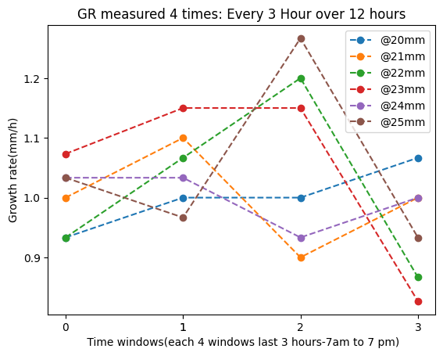

**Generalised Differential GR for each size:**

GR for each size: [1.0, 1.0, 1.017, 1.049, 0.99]

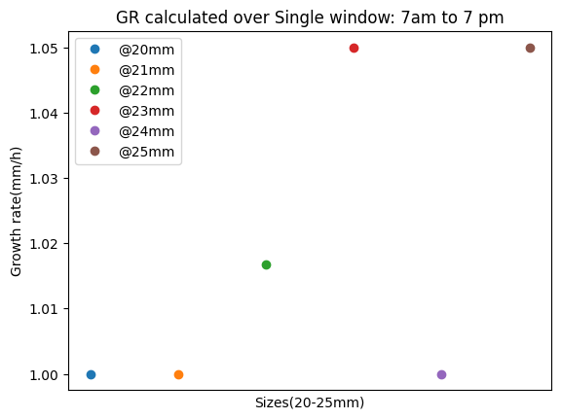

**Inference:**

1. Growth rate is more likely to change over time. To achieve précised growth rate this calculation needs to be performed in a shorter window. PD technique addresses this.
2. Growth rate has been calculated 4 times in 4-time windows. It seems the change in every time window GR is not huge, and the variation of change is +-10%
3. At the end to get generalised Growth rate for each 4 sets a generalised GR was calculated taking mean over 4 sets

[[0.9333, 1.0, 1.0, 1.0667], [1.0, 1.1, 0.9, 1.0], [0.9333, 1.0667, 1.2, 0.8667], [1.0733, 1.15, 1.15, 0.8267], [1.0333, 1.0333, 0.9333, 1.0]]

GR over PD technique:

In this method, the dataset was divided into each hour and then growth rate was calculated using data from two pairs and comparting with others.

**Growth**= 8am size-7am size , 9am size-8am size and so on

**Growth rate**=K-mean centroid(Growth)

K-mean centroid makes two clusters out of the whole set of growth rate series one where most of the growth rates lie and the other where few extreme rates lie. It differentiates those cluster centroids and find the most meaningful cluster that best represent the growth rate for the whole set.

[GR_PDTechnique.py](https://universityoflincoln-my.sharepoint.com/:u:/g/personal/akundu_lincoln_ac_uk/Eba5BgAW94RNvBLExkIFwtMBP_I5uG9lqe3ZlZiVHmyfmw?e=XQodIJ) will take data from excel and produce the following report

**Note:** the experiment over finding Growth Rate(GR) was calculated just for sizes: 20mm, 21mm, 22mm,23mm,24mm to avoid long repetitive calculation.

Inference:

1. Growth rate can be précised when it is calculated with PD technique as it adepts the variation over GR every hour and then K-means cluster centroid gives a final single value over a whole 13 sets of growth rate observed within a 12 hours window.

Results:

*** General growth rate considering 1 hour pair data*** ---Growth rate/ growth per hours over 12 hours for each sizes from 20 to 25mm(in list)--- 7 am to 7pm

Hour basis Growth rate:

20mm>>> [1, 0.8, 1.0, 0.9, 0.8, 1.3, 0.9, 0.9, 1.2, 0.95, 0.95, 1.3]

21mm>>> [1, 1.1, 0.9, 0.9, 1.1, 1.3, 0.8, 0.9, 1, 1.2, 0.8, 1]

22mm>>> [1.1, 0.9, 0.8, 1.1, 1.3, 0.8, 1.1, 1.4, 1.1, 0.9, 0.8, 0.9]

23mm>>> [1.15, 0.92, 1.15, 0.46, 1.15, 1.84, 0.46, 1.38, 1.61, 0.88, 1, 0.6]

24mm>>> [1, 1.16, 0.94, 0.74, 1.2, 1.16, 0.9, 0.9, 1, 0.9, 1.1, 1],

25mm>>>[1, 1.1, 1.0, 0.9, 1.25, 0.75, 1.6, 0.4, 1.8, 0.6, 1.0, 1.2]]

Generalised Differential GR for each size:

Local clusterised GR: [0.91, 0.91, 0.85, 0.72, 0.92, 0.84]

Single clusterised GR: [1.0, 1.0, 1.02, 1.05, 1.0, 1.05]

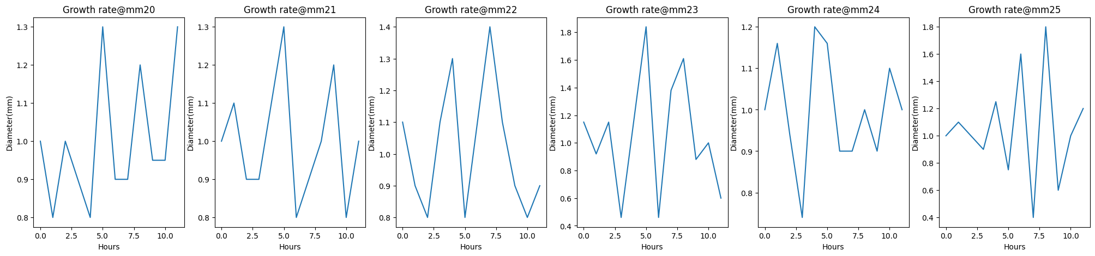

Growth rate comparison between Full cycle analysis and PD techniques

|  |  |
| --- | --- |
| Full cycle analysis | Pair Differential techniques |
| [1.0, 1.0, 1.017, 1.05, 1.0, 1.05] | [0.91, 0.91, 0.85, 0.82, 0.92, 0.84] |

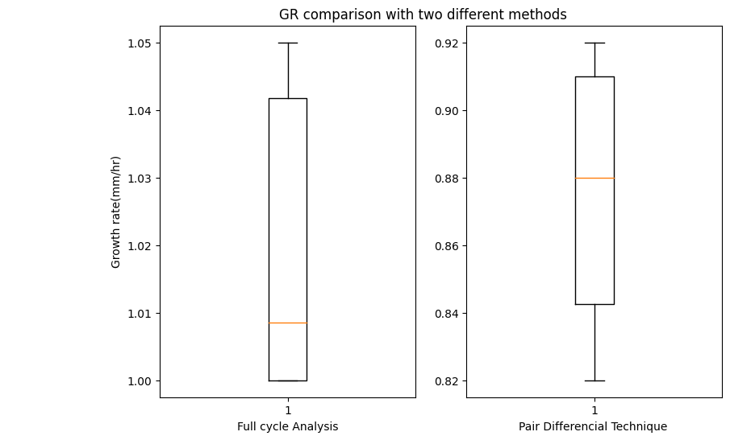

Best method to choose for growth rate calculation:

PD technique give most likely to happen Growth rate for each size of mushrooms while Full cycle analysis gives Growth rate what is more like generalized (averages) for each size of mushrooms.